**PATIENT MONITORING SYSTEM USING NODEMCU**

T.SHIVAANI(17311A19E5)

G.AKHIL RAO(17311A19G4)

M.SRINIHA RAO(17311A19H7)

**ABSTRACT:**

With an improvement in technology and miniaturization of sensors, there have been attempts to utilize the new technology in various areas to improve the quality of human life. One main area of research that has seen an adoption of the technology is the healthcare sector. The people in need of healthcare services find it very expensive this is particularly true in developing countries.

As a result, this project is an attempt to solve a healthcare problem currently society is facing. The main objective of the project was to design a remote healthcare system. It’s comprised of three main parts. The first part being, detection of patient’s vitals using sensors, second for sending data to cloud storage and the last part was providing the detected data for remote viewing. Remote viewing of the data enables a doctor or guardian to monitor a patient’s health progress away from hospital premises.

The Internet of Things (IoT) concepts have been widely used to interconnect the available medical resources and offer smart, reliable, and effective healthcare service to the patients. Health monitoring for active and assisted living is one of the paradigms that can use the IoT advantages to improve the patient’s lifestyle. In this project, I have presented an IoT architecture customized for healthcare applications. The aim of the project was to come up with a Remote Health Monitoring System that can be made with locally available sensors with a view to making it affordable if it were to be mass produced.

Hence the proposed architecture collects the sensor data through Arduino microcontroller and relays it to the cloud where it is processed and analyzed for remote viewing. Feedback actions based on the analyzed data can be sent back to the doctor or guardian through Email and/or SMS alerts in case of any emergencies.

Keywords: Arduino, IoT, data

acquisition unit, mobile application etc

1. **INTRODUCTION:**

Health monitoring is the major problem in today’s world. Due to lack of proper health monitoring, patient suffer from serious health issues. There are lots of IoT devices now days to monitor the health of patient over internet. Health experts are also taking advantage of these smart devices to keep an eye on their patients. With tons of new healthcare technology start-ups, [IoT](https://circuitdigest.com/internet-of-things-iot-projects) is rapidly revolutionizing the healthcare industry. With many new health technology companies, IoT is rapidly revolutionizing the healthcare industry. In this project, we developed an IoT-based patient health monitoring system with ESP8266 . The IoT platform used in this project is Adafruit. Here in this project, we will make an **IoT based Health Monitoring System** which records the patient heart beat rate and also send an email/SMS alert whenever those readings goes beyond critical values. Pulse rate readings are recorded over Adafruit and Google sheets so that patient health can be monitored from anywhere in the world over internet.

1. 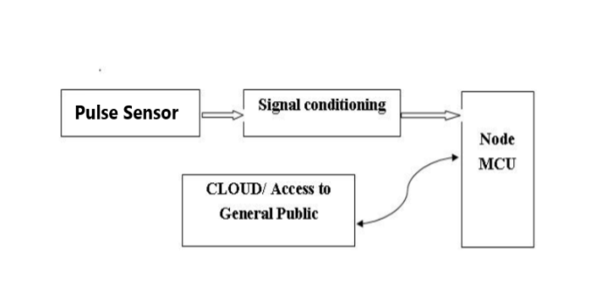 **EXISTING SYSTEM:**

* Diagnosing with the help of a doctor.
* Approaching doctor for small problems.
* No automated system exists.
* Smart watches are expensive and not specifically for healthcare.

1. **PROPOSED SYSTEM:**

* In this project, a system for 24x7 human health monitoring is designed and implemented.
* In this system, the Arduino Uno board is used for collecting and processing all data.
* Different sensors are used for measuring different parameters.
* All this data is uploaded to adafruit for remote analysis.
* An ESP8266 module is used for connecting to the internet.
* Blynk app is used for finding the location and sending messages.

1. **BLOCK DIAGRAM:**

Fig 4.1 **:**Block diagram of patient monitoring system

1. **WORKING:**

With many new health technology companies, IoT is rapidly revolutionizing the healthcare industry. In this project, we developed an IoT-based patient health monitoring system with ESP8266. The IoT platform used in this project is Adafruit. Adafruit is an open source Internet application (IoT application) and an API for storing and retrieving data using HTTP over the Internet or a local area network. This IoT device could read the pulse rate . It continuously monitors the pulse and updates them on an IoT platform.

The Arduino sketch that traverses the device implements the various project functions, such as reading sensor data, converting to strings, transmitting them on the IoT platform, and displaying the pulse measured on the IoT platform. This is a simple circuit diagram that explains the IoT-based Patient Health Monitoring System using ESP8266. The pulse sensor sensor measure BPM. The IoT server used here is Adafruit. Finally, data can be monitored from any part of the world by connecting to the Adafruit channel. Here in this project, we will make an **IoT based Health Monitoring System** which records the patient heart beat rate and body temperature and also send an email/SMS alert whenever those readings goes beyond critical values. Pulse rate readings are recorded over Adafruit and Google sheets so that patient health can be monitored from anywhere in the world over internet.

1. **RESULT:**

Pulse sensor is working and we can see the daily feed in AdafruitIO and we can get the loction of the patient from blynk app that is installed on the patient’s mobile.

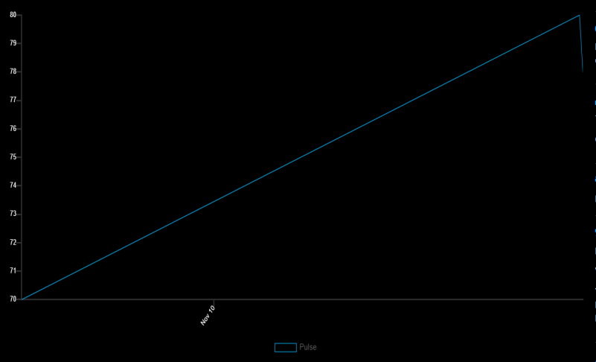

Fig 6.1: pulse-time graph

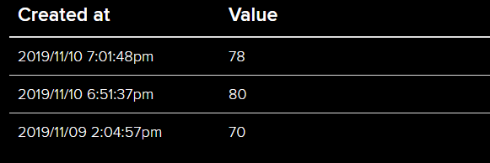

Fig 6.2: pulse values at certain time and date

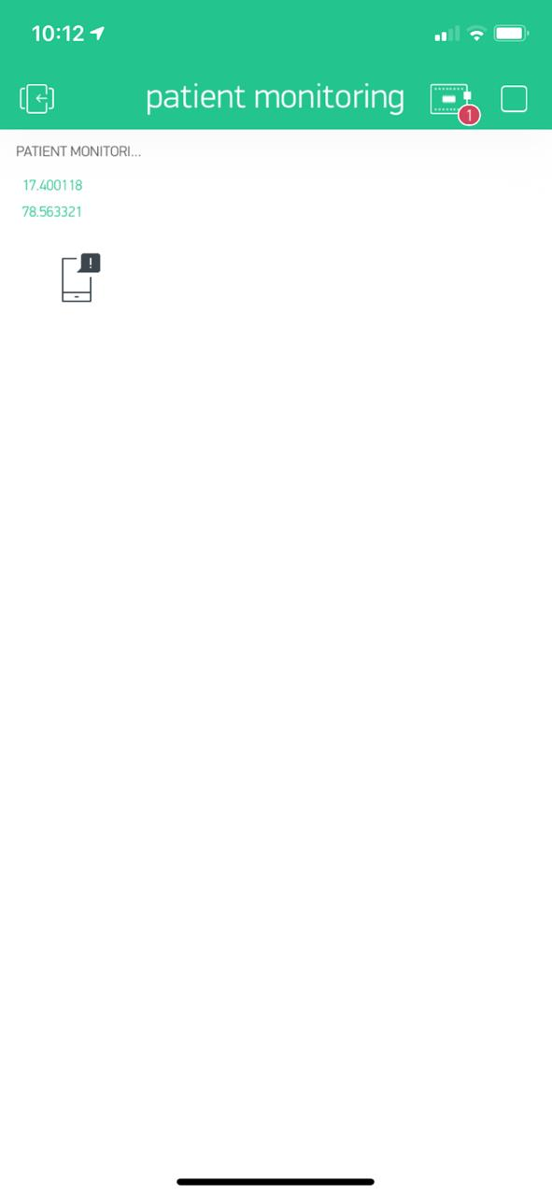

Fig 6.3: Location coordinates from blynk app

1. **APPLICATIONS:**

* It can be operated remotely by interfacing a message sending system through app.
* It can be used in ICUs , operation theaters , monitoring of oxygen levels etc..
* It can be also used in old age homes to monitors the various parameters of a sick person in old age homes.

**REFERENCES:**

1. <https://en.wikipedia.org/wiki/NodeMCU>.
2. <https://www.adafruit.com/>
3. <http://docs.blynk.cc/>
4. <https://components101.com/sensors/pulse-sensor>
5. <http://eknygos.lsmuni.lt/springer/56/585-625.pdf>
6. <https://circuitdigest.com/microcontroller-projects/iot-based-patient-monitoring-system-using-esp8266-and-arduino>